1. 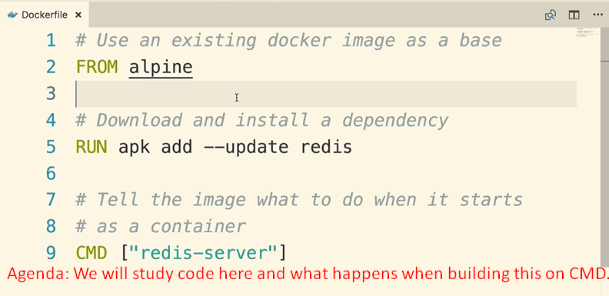
2. 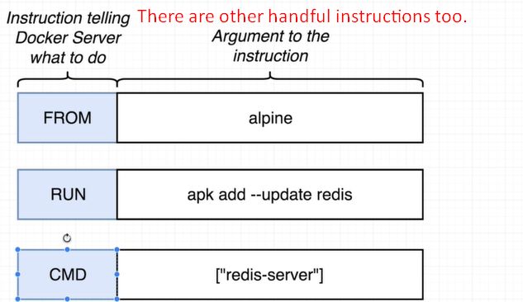
   1. The first word tells Docker Server to do some very specific preparation step on image.
   2. **FROM**: To specify the docker image that we want to use as base.
   3. **RUN:** To execute some commands while we’re preparing custom image.
   4. **CMD:** Command instruction specifies what should be executed when this custom image is used to start up a brand new container.